**IST659 – Data Admin Concepts & Db Mgmt**

**Lab 8 - Ramasamy Seenivasagamani – Sanjeev**

**1. Company and Position(s) Form: Create a Master-Detail form (form/subform) that will**

**allow you to add Company and their positions. Display all the Company attributes. Add a sub**

**form for positions offered by the company and display all position attributes (Company ID**

**may or may not be there since all the positions listed under the company belong to the**

**company). This form should allow adding and deleting both companies and their offered**

**positions. You may need to add a button to delete a company. Attach screen shots of your**

**input Forms and proof that they work properly. For example, add and delete records. Use**

**results of SELECT queries to show the results of the insertions and deletions using the forms.**

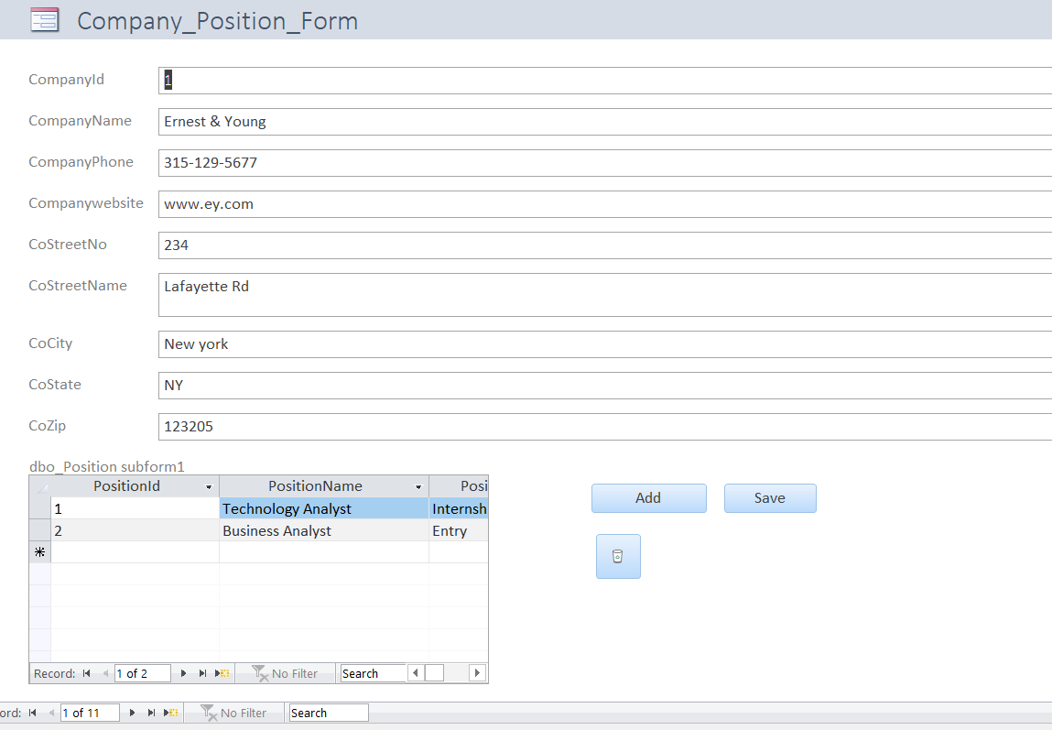

Adding a new record through the form:

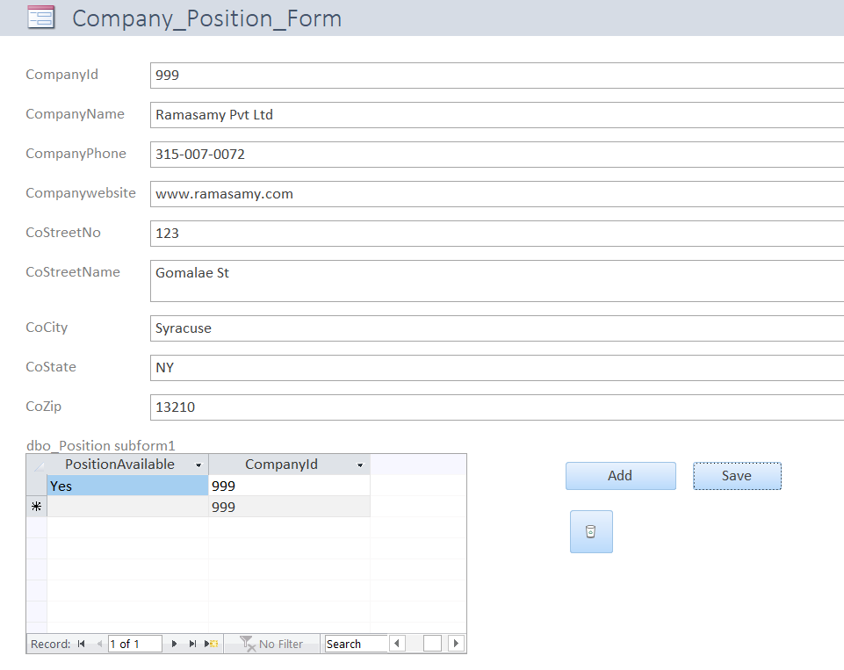

Confirmation:

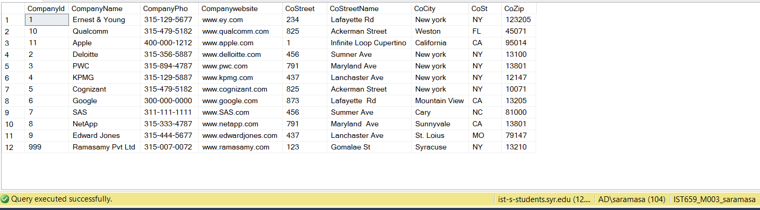

Position:

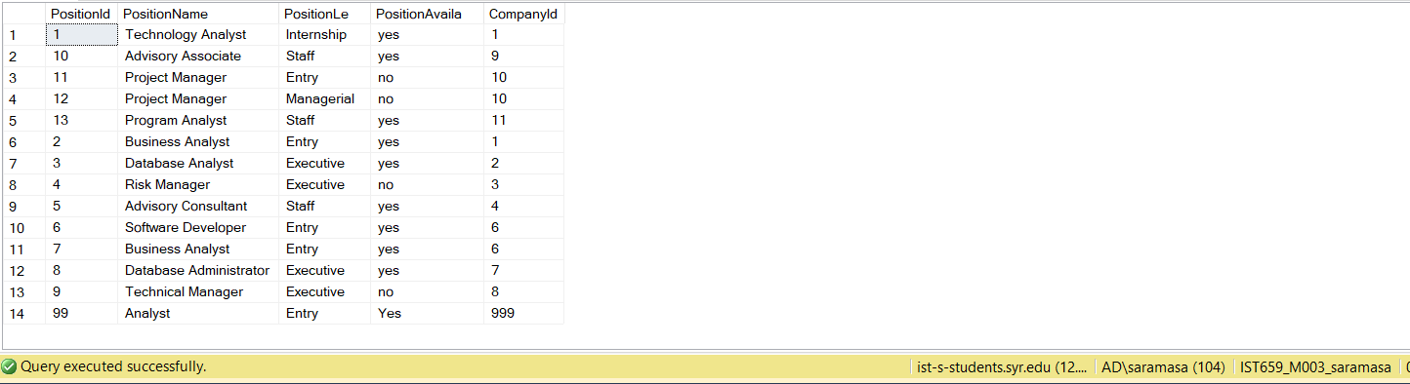

Deletion Confirmation:

Company:

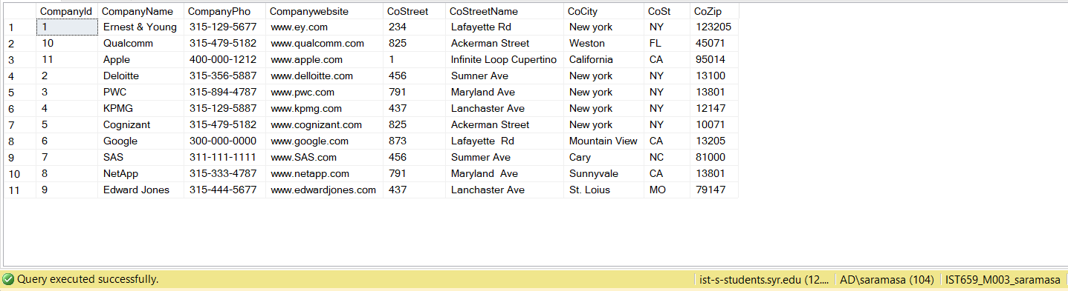

Position:

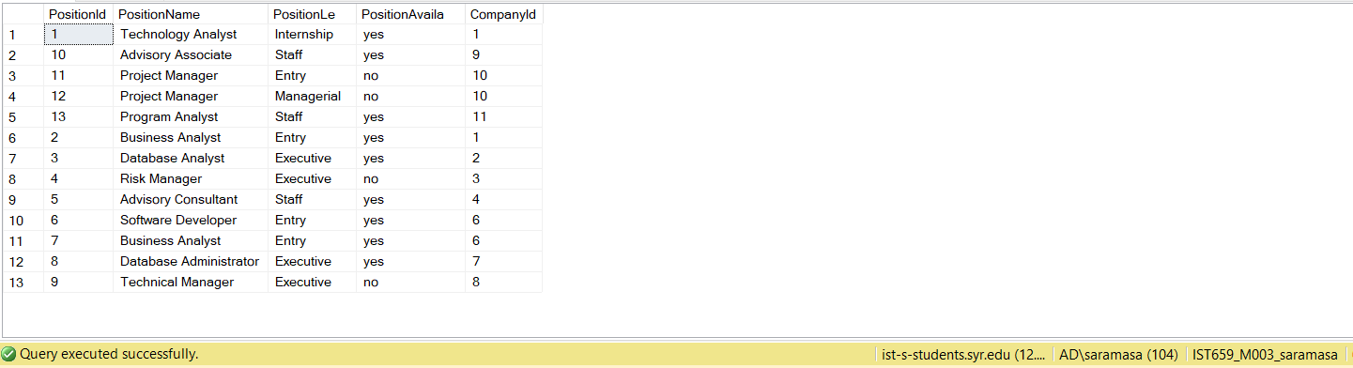

**2. Candidate and Interview Form: Create a master-detail form (form/subform) in MS Access**

**that will allow you to select a particular Candidate and display the Interview details for that**

**Candidate. Attach screen shots of your form and proof that it works properly.**

**Adding New Record:**

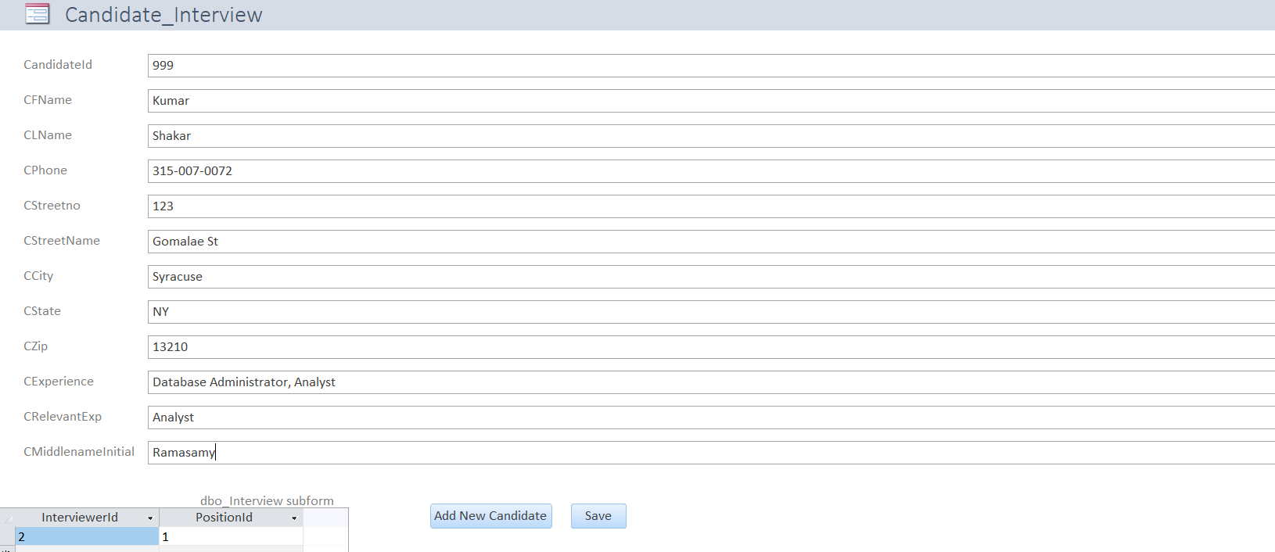

**Addition Confirmation:**

**Candidate:**

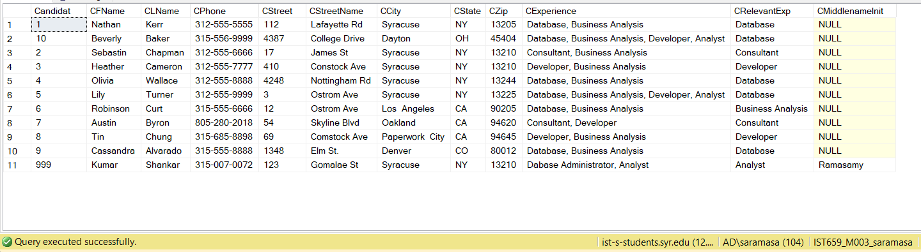

**Interview:**

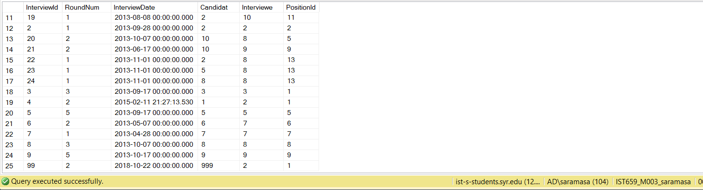

**Deletion Confirmation:**

**Candidate:**

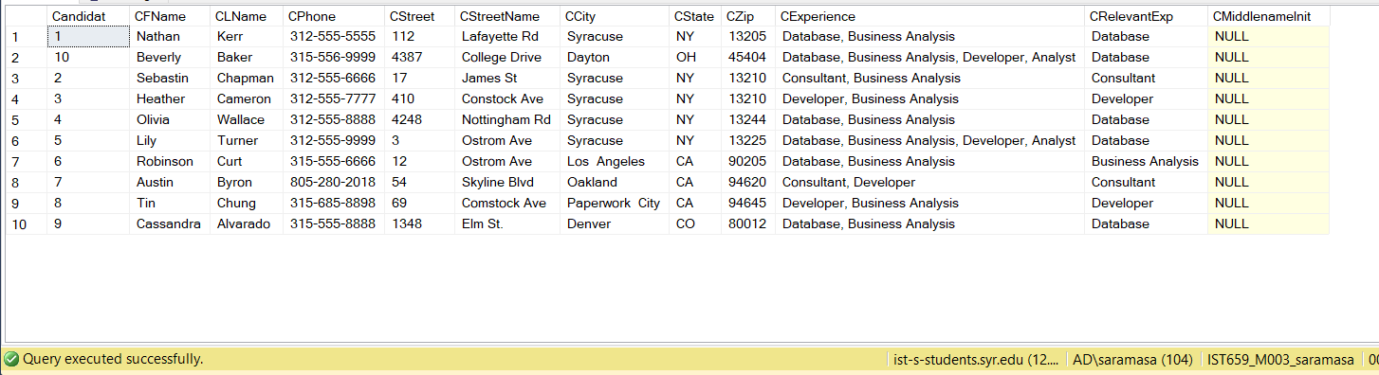

**Interview:**

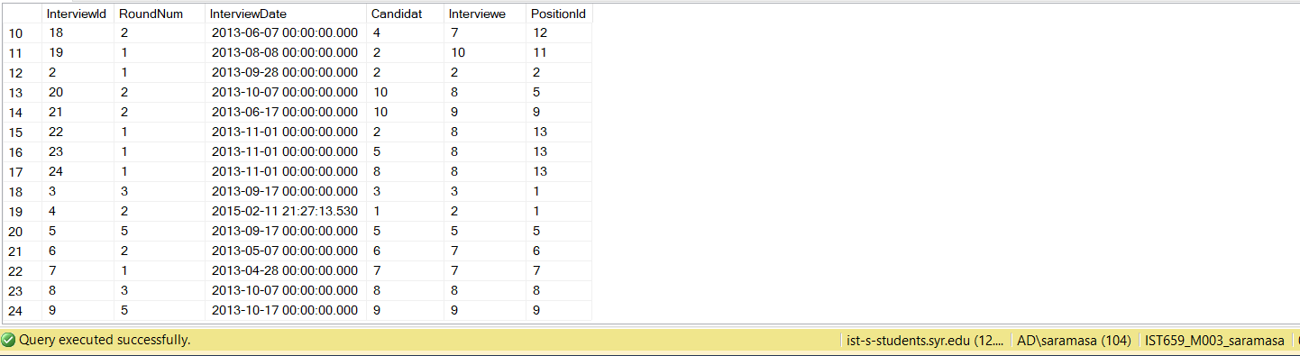

**3. Interview Summary Report: Create a report that lists all Interviews information including**

**Interviewer ID, Interviewer’s last name and first name, Candidate ID, Candidate last and first**

**name, Interview ID, and Interview date. Order the report by Interview Date. Also list all**

**positions for which interviews were conducted displaying Position ID, Position name,**

**Position Level. Attach screen shots of your report.**

